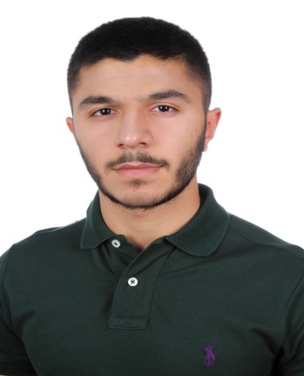Mohamed Moosa Sharif

# Objectives & Goals:

* Implement all rules and guidelines
* Assist, improve, and provide a hard working environment
* Operate with speed, quality, and excellence

# Personal details:

Full Name: Mohamed Moosa Salman Faredoon Mohamed Sharif

Nationality: Bahraini

Date of birth: 2/06/2001

Gender: Male

Status: Single

Address: House 2895 Road 5547 Block 255 Galali Bahrain

Mobile: +973 33447706

Email: [Mohamedsharif078@gmail.com](mailto:Mohamedsharif078@gmail.com)

Languages: Arabic-English-Spanish-Indian

CPR Number: 010600361

# Education:

2007-2019 Modern Knowledge School

(American Diploma)

# Skills:

* Excellent communicator
* Team Player
* Highly disciplined
* Exceptional at problem solving

# Experience:

* Staff Member at Brave Combat Federation (2018-2019)
* Organizer at International Mixed Martial Arts Combat Week Bahrain (2018-2019)
* Organizer at Model United Nations at Modern knowledge Schools (2018-2019)

# Awards/Recognition:

* Honor Roll for having secured the highest marks in the academic year of (2018-2019)
* Basketball League 1st place in the academic year (2014-2015-2016-2017-2018-2019)
* IELTS TEST 6.0 overall
* 1st place in in track and field league at 6 different categories (2018-2019)
* Best Debating Skills at AHIS model united nations (2017)
* Participation at AHIS MUN (2017)
* Participation at KMUN (2018)

# Hobbies:

* Swimming
* Helping others
* Reading
* Exploring new languages and countries

(References available upon request)